Housing Vouchers
Student’s Name
Institutional Affiliation

Housing Vouchers
The housing program is one of the most important programs the federal government has used to enhance the livelihood of many poor families. The program has helped more than 2.8 million low-income families so far. This program is the country’s most important program as it lifts the livelihoods of its citizens. In this program, the recipients pick a house available and only contribute 30% of its value in rent while the government pays the 70% (Varady, 2010).
Different from the nuclear families that have not been helped for all levels of pay, the recipients of vouchers will pay high and very costly lodging costs and live in high quality lodging facilities (Pergamit, Cunningham & Hanson, 2017). Given that the current voucher programs are dependent on the prevailing lodging stock, Pergamit, Cunningham and Hanson (2017) observes that they are “less over the top than programs that produce new pursuits for inhabitancy by defective individuals.” Most importantly, lodging vouchers enable the recipients to choose the region in which they want to pick the lodging facilities from.
It is worth noting the import role the government has taken in issuing lodging facilities to families. Families have been helped by these programs to have quality housing. This is in relation to families staying in low-pay regions, those in central city neighbourhoods and those in racially afflicted regions to afford some quality housing regardless of their economic situation. For instance, Pergamit, Cunningham and Hanson (2017) observed that about 37% of open lodging inhabitants live in places where the poverty level is above 40%. Moreover, most of these settlements are inhabited by the African-Americans and the places are predominantly dim.
Housing programs have been helpful such as the Low-Income Housing Tax Credit and the HOME Program have been helpful to the poor in their neighbourhood. The program has been used to enhance the livelihood of the less privileged in the society by helping them get quality housing facilities. For instance, almost all LIJTC units are managed in dull areas (Varady, 2010). As a result, about 1.7 million low remuneration individuals and families have been able to benefit from quality housing programs (Pergamit, Cunningham & Hanson, 2017). As a result, the housing program has enabled most people to have basic housing through this program.
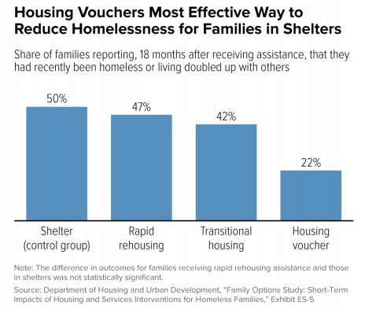
Figure 1: Effect of House voucher program on reducing homelessness (Fischer, 2015).
Housing vouchers program have been proven to play a critical role in poverty alleviation among the poor families. In 2014 alone, about 2.8 million people including approximately 900, 0000 children benefited from the program when the Federal government intervened (Fischer, 2015). This is one of the methods of accounting for non-cash benefits issued out by the government to its people. Half of the effect created by the federal government help was created by the housing voucher program. Studies have already indicated the significant effects of poverty, especially on children (Varady, 2010). These effects include hampering their natural and smooth development. Studies have also indicated that children hailing from poor backgrounds and who receive additional income have higher chances of doing better in school intervened (Fischer, 2015).
Reducing the families’ rental costs and giving them assistance with housing enables them to focus on more issues such as meeting their basic needs. For instance, families will shifts their monies to attending to basic needs rather than rent and housing given that they now have assistance. This can also go a long way in families focusing on issues such as clothing, food, healthcare, education, and transportation. This goes a long way in enhancing the cognitive development of children hailing from such backgrounds as it is estimated that children pay at least 30% of their household income (Fischer, 2015). However, given that the responsibility to cater for household rental income has been lifted from their parents by the government, parents can now focus on other things enabling their children to enjoy school and develop better. This enables the parents to invest more in other activities and things that will support the cognitive development of their children.
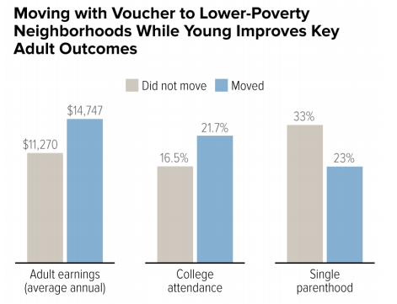
Figure 2: Effect of House voucher program on poverty alleviation (Fischer, 2015).
The program should be continued following its greater impact; especially in helping poor families cope as well as helping their children develop higher cognitive abilities. The government should continue supporting poor families by offering them housing vouchers (Fischer, 2015. This will enable the families to support their families by offering other basic requirements such as food, clothing, healthcare, and education. The family will also be able to invest the other monies they have as the housing burden has been lifted from them by the government.

References
Fischer, W. (2015). Research shows housing vouchers reduce hardship and provide platform for long-term gains among children. Washington, DC: Center on Budget and Policy Priorities.
Pergamit, M., Cunningham, M., & Hanson, D. (2017). The impact of family unification housing vouchers on child welfare outcomes. American journal of community psychology, 60(1-2), 103-113.
Varady, D. (2010). What should housing vouchers do? A review of the recent literature. Journal of Housing and the Built Environment, 25(4), 391-407.

